**Trajectory Planning**

Assume the angle to be a cubic function of time

$θ\left(t\right)=A+Bt+Ct^{2}+Dt^{3}$------- Equation 1

Boundary Conditions:

$θ\left(0\right)= θ_{i}$

$θ\left(t_{f}\right)= θ_{f}$

Initial and Final Conditions:

$\frac{d^{2}θ }{{dt}^{2}}(0)=0$

$\frac{d^{2}θ }{{dt}^{2}}(t_{f})=0$

Solving the Equation 1 with the above conditions

$$θ\left(t\right)=i+3\left(\frac{\left(f- i\right)}{{t_{f}}^{2}}\right)t^{2}-2\left(\frac{\left(f- i\right)}{{t_{f}}^{3}}\right)t^{3}$$

$$\frac{dθ\left(t\right)}{dt}=6\left(\frac{\left(f- i\right)}{{t_{f}}^{2}}\right)t-6\left(\frac{\left(f- i\right)}{{t_{f}}^{3}}\right)t^{2}$$

$$\frac{d^{2}θ\left(t\right)}{dt^{2}}= 6\left(\frac{\left(f- i\right)}{{t_{f}}^{2}}\right)-12\left(\frac{\left(f- i\right)}{{t_{f}}^{3}}\right)t$$

$$t_{f} is time taken for a single PTP translation$$

$$As per the cubic relation of angle with time, the angular acceleretion at t_{0} and t_{f} is assumed to be 0.$$

$$Value of t_{f} depends on the maximum acceleration required as the usecase$$

$$at t=0$$

$$t_{f}= \sqrt{\frac{6\left(f- i\right)}{α}}$$

EXAMPLE:

The end effector moves from A (0,0, -327.161) to B (50,0, -327.161)

* Calculate the angles using Inverse Kinematics

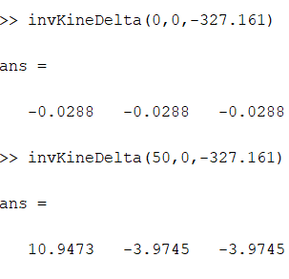

$angular acceleration is set to 0.5\frac{{rad}^{2}}{s} then t_{f} is 11.46 s$

Angular velocity – Parabolic

Angular acceleration – linear

